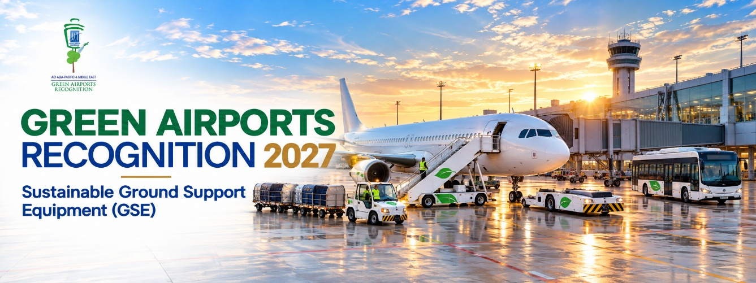
Part I- Programme Description

Background and Objective
The ACI Asia-Pacific & Middle East Green Airports Recognition promotes environmental best practices to minimise aviation’s impact on the environment and recognises airport members who have outstanding accomplishments in environmental sustainability projects.
This initiative allows airports to share environmental sustainability projects with other airports in the region and be recognised for their achievements.
Initiative Topics - Environment
The environmental field encompasses the following key themes, from which a topic will be selected for the Green Airports Recognition each year:
- Air quality
- Biodiversity
- Carbon
- Climate Change Adaptation
- Energy
- Environmental Policy and Management (including green procurement)
- Ground transportation
- Land & water contamination
- Noise
- Water (including both municipal water usage and wastewater discharge)
- Waste
- Others
Green Airports Recognition 2027 – Sustainable Ground Support Equipment
To meet the Paris Agreement's target of limiting global warming to no more than 1.5°C, emissions must be reduced by 45% by 2030 and reach net zero by 2050. In response to these global imperatives, airports across the region continue to adopt initiatives aligned with net zero carbon goals. Airports are keeping efforts to reduce carbon emissions, driving the aviation industry's shift toward sustainable and low-carbon operations through initiatives such as ground operations electrification and infrastructure efficiency improvements. As per the Intergovernmental Panel on Climate Change (IPCC) aviation contributes only about 2-3% of total global emissions, airport operators are in a unique position to lead and demonstrate initiatives in climate change mitigation, given the significant share of Scope 3 emissions generated at the airside and landside interface. Ground Support Equipment (GSE) – including baggage tractors, belt loaders, pushback tugs, ground power units, air-conditioning units, and water and lavatory service vehicles etc. – remains one of the key sources of these emissions, as a large proportion of the fleet at many airports is still powered by diesel and gasoline engines. Transitioning these fleets to sustainable alternatives can reduce Scope 1 emissions, which are direct emissions from equipment and activities controlled by the airport, while also helping reduce Scope 3 emissions, which come from activities by other organisations operating at the airport, such as airlines and ground handling service providers. This transition also improves local air quality and reduces noise on the ramp, directly benefiting ground staff and surrounding communities. Airports can collaborate with stakeholders such as airlines, ground handling service providers, and equipment manufacturers to accelerate the transition to Sustainable Ground Support Equipment (Sustainable GSE), across all operating fleets. This includes investment in shared charging and alternative fuel infrastructure and workforce training for the safe operation and maintenance of sustainable fleets. This transition also requires airports to plan the associated power, grid, and fuel supply infrastructure demands, working with utility providers and financiers to ensure a smooth and cost-effective rollout.
The Green Airports Recognition 2027 – marking its eleventh edition-- invites airports in the Asia-Pacific and Middle East regions a platform to showcase their innovative initiatives in Sustainable Ground Support Equipment while contributing to the region's broader decarbonisation goals. All member airports of ACI Asia-Pacific & Middle East are invited to participate by submitting their innovative initiatives and projects on Sustainable Ground Support Equipment (Sustainable GSE), encompassing Scope 1 and/or Scope 3 emissions. Airports are encouraged to highlight tangible measures, lessons learned, and best practices related to sustainable GSE. By sharing these examples, airports can inspire peers across the region and contribute to a more sustainable and climate-resilient future for aviation. Best practices include sustainable GSE fleet deployment (e.g., electric, hybrid, hydrogen, renewable diesel etc.), charging and alternative fuel infrastructure, phase-out of conventional diesel/gasoline-powered equipment, and collaborative programs targeting Scope 3 reductions.

The call for Green Airports Recognition 2027 submissions is now open!
All eligible member airports across Asia-Pacific and the Middle East are invited to participate by submitting their innovative initiatives and projects on Sustainable Ground Support Equipment (GSE). We encourage airports to showcase their efforts in transitioning to low-emission and zero-emission GSE fleets, improving operational efficiency, reducing fuel consumption, and enhancing air quality. Submissions may cover a wide range of areas, including electrification of GSE, renewable energy integration for charging infrastructure, fleet modernisation, alternative fuels, smart fleet management systems, operational optimisation, maintenance best practices, staff training, and stakeholder collaboration to support sustainable ground operations.
Eligibility
- Applicants must be active ACI Asia-Pacific & Middle East’s airport members
- Applicants must complete Environmental Survey 2025
- Submitted project or initiative must be completed within last five years (2022 to 2026)
How to Apply
The participating airport is required to submit the completed application form to ACI Asia-Pacific & Middle East. (Only one project in one application per airport operator)

Important Dates
Submission deadline: 23 December 2026, 12:00 Noon HKG Time (GMT+8)
Result announcement: Within Q1 2027
Presentation Ceremony: ACI Asia-Pacific & Middle East Regional Assembly,
Conference and Exhibition (Kuala Lumpur, Malasia), May 2027
Judging Process and Criteria
Eligibility review: All applications will be reviewed (project completion date, word limit prescribed etc.) by ACI APAC & MID.
Panel assessment: Each eligible submission will be evaluated based on the judging criteria by a Panel comprising ACI APAC & MID, academia and experts in the airport environmental field worldwide.
Nominated environmental projects will be assessed based on the following seven criteria, on a scale of 0 to 4 (4 = Excellent; 3 = Good; 2 = Satisfactory; 1 = Fair; 0 = No evidence).
- Environmental Awareness & Benefit
- Company Management Involvement
- Cost Effectiveness
- Innovation
- Stakeholder Engagement
- Social Benefit
- Applicability
Award Categories
Platinum, Gold and Silver recognitions will be given to the three highest-scoring airports in each size category (depending on the number of participants) based on the judging criteria.
Selected submissions will be featured in the Green Airports Recognition publication and outstanding airports will be recognised with our sustainability credential and be invited to the award presentation ceremony at the ACI APAC & MID Regional Assembly, Conference and Exhibition 2027 (RACE) in Kuala Lumpur on 13 May 2027* along with their achievements highlighted in ACI APAC & MID’s press campaign.
*To be confirmed
Enquiries
For enquiries, please contact Mr. Ken Lau, Head, Sustainability, and Mr. Mohan Sai Gurugubelli, Manager, Sustainability & Environment at green_airports@aci-asiapac.aero
Part II – Application Form
Section A – Entrant Particular
Airport Operator (only 1 project per airport operator):
Airport: | IATA code:
Contact Person (Name & Designation):
Tel. No.: | Email:
Section B – Project details
Project Name: | Completed date:
Website link (if any)
Section C – Declarations
By submission of this form, I agree to the report being published and publicised at the discretion of ACI Asia-Pacific & Middle East. I agree that ACI Asia-Pacific & Middle East and/ or the Panel of Judges have full authority to make final decisions on all matters relating to the “ACI Asia-Pacific & Middle East Green Airports Recognition” without obligation to disclose the reasons.
Signature of Official/ Alternate Representative/ Senior Management: |  | Name:
 |  | Designation:
 |  | Date:
Section D – Important Note
- Please submit (1) a completed Application Form in MS Word and (2) a scanned copy of this page with a signature to green_airports@aci-asiapac.aero on or before 23 December 2026, 12:00 noon Hong Kong Time (GMT+8) [strict deadline].
- Please provide details of only one project in one application per airport operator.
- Please contact us if you do not receive an acknowledgement email from the ACI Asia-Pacific & Middle East Regional Office within three working days after your submission.

Executive Summary
Provide a brief summary of the project for ACI’s future publications. (max 300 words)
Project Background
Describe where, when and why the project was needed. (max 100 words)

Project Scope
Describe the operational boundary of the project, e.g. airside only, terminal only, airport-wide etc. and stakeholders involved, e.g. airport staff, regulators, NGOs and environmental groups etc. (max 50 words)

Project Description
Describe how the project was delivered, e.g. retrofit, new project as well as funding.
(max 150 words)

Project Results and Benefits
List your project achievements and supporting evidence and summarize its relevance to the judging criteria, e.g., factual data, actual cost saved, recognized environmental benefits and evidence of innovation. (max 300 words)

Project graphics
Maximum 4 graphics with captions e.g., photos, charts etc. This part will be considered for future ACI publications. Provide a caption for each graphic and keep the graphics within one A4 page.
Caption 1: | Caption 2:
INSERT A PICTURE HERE | INSERT A PICTURE HERE
Caption 3: | Caption 4:
INSERT A PICTURE HERE | INSERT A PICTURE HERE

